**Writeup Template**

**You can use this file as a template for your writeup if you want to submit it as a markdown file, but feel free to use some other method and submit a pdf if you prefer.**

**Advanced Lane Finding Project**

The goals / steps of this project are the following:

* Compute the camera calibration matrix and distortion coefficients given a set of chessboard images.
* Apply a distortion correction to raw images.
* Use color transforms, gradients, etc., to create a thresholded binary image.
* Apply a perspective transform to rectify binary image ("birds-eye view").
* Detect lane pixels and fit to find the lane boundary.
* Determine the curvature of the lane and vehicle position with respect to center.
* Warp the detected lane boundaries back onto the original image.
* Output visual display of the lane boundaries and numerical estimation of lane curvature and vehicle position.

[**Rubric**](https://review.udacity.com/#!/rubrics/571/view) **Points**

**Here I will consider the rubric points individually and describe how I addressed each point in my implementation.**

**Writeup / README**

**1. Provide a Writeup / README that includes all the rubric points and how you addressed each one. You can submit your writeup as markdown or pdf.** [**Here**](https://github.com/udacity/CarND-Advanced-Lane-Lines/blob/master/writeup_template.md) **is a template writeup for this project you can use as a guide and a starting point.**

You're reading it!

**Camera Calibration**

**1. Briefly state how you computed the camera matrix and distortion coefficients. Provide an example of a distortion corrected calibration image.**

The code for this step is contained in the fourth code cell of the IPython notebook located in “. / Lanedetection.ipynb".

I start by preparing "object points", which will be the (x, y, z) coordinates of the chessboard corners in the world. Here I am assuming the chessboard is fixed on the (x, y) plane at z=0, such that the object points are the same for each calibration image. Thus, objp is just a replicated array of coordinates, and objpoints will be appended with a copy of it every time I successfully detect all chessboard corners in a test image. imgpoints will be appended with the (x, y) pixel position of each of the corners in the image plane with each successful chessboard detection.

I then used the output objpoints and imgpoints to compute the camera calibration and distortion coefficients using the cv2.calibrateCamera() function. I applied this distortion correction to the test image using the cv2.undistort() function and obtained this result:

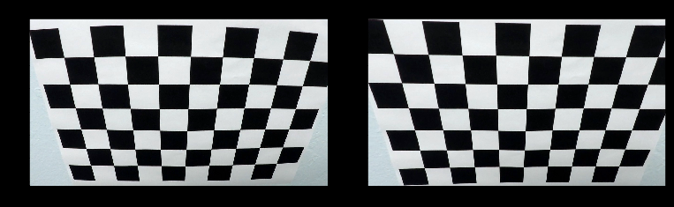

**Pipeline (single images)**

**1. Provide an example of a distortion-corrected image.**

To demonstrate this step, I will describe how I apply the distortion correction to one of the test images like this one:

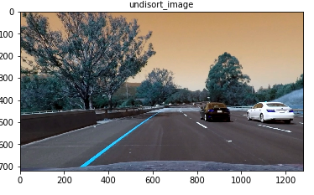

**2. Describe how (and identify where in your code) you used color transforms, gradients or other methods to create a thresholded binary image. Provide an example of a binary image result.**

I used a combination of color and gradient thresholds to generate a binary image code cell 6 and 7 Here's an example of my output for this step. (note: this is not actually from one of the test images)

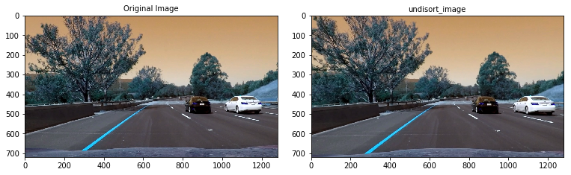

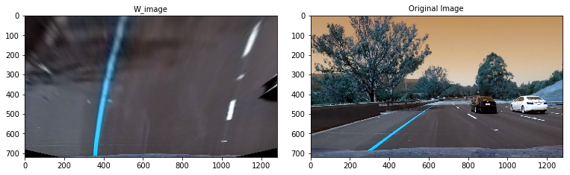

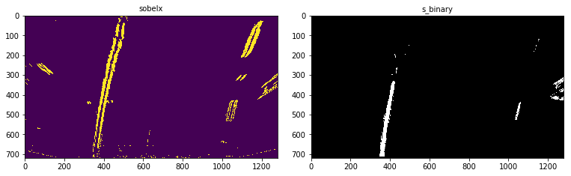

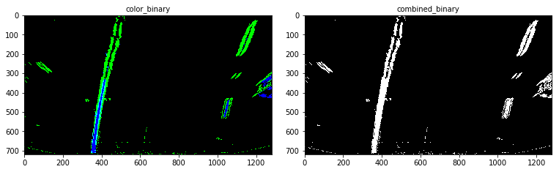

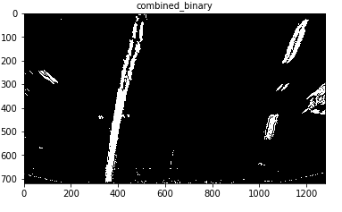

**3. Describe how (and identify where in your code) you performed a perspective transform and provide an example of a transformed image.**

The code for my perspective transform includes a function called wrap_transform() which appears in code cell 6 or, for example, in the 3rd code cell of the IPython notebook). The warper() function takes as inputs an image (img), as well as source (src) and destination (dst) points. I chose the hardcode the source and destination points in the following manner:

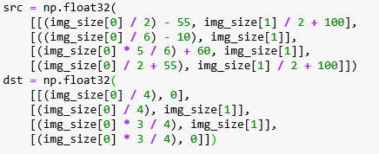

This resulted in the following source and destination points:

| **Source** | **Destination** |
| --- | --- |
| 585, 460 | 320, 0 |
| 203, 720 | 320, 720 |
| 1127, 720 | 960, 720 |
| 695, 460 | 960, 0 |
|  |  |

I verified that my perspective transform was working as expected by drawing the src and dst points onto a test image and its warped counterpart to verify that the lines appear parallel in the warped image.

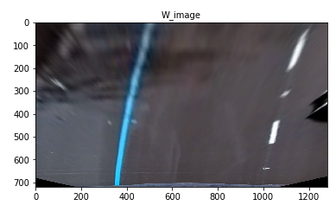

**4. Describe how (and identify where in your code) you identified lane-line pixels and fit their positions with a polynomial?**

Step 1: Undisort Image.

Step 2: Binary Image.

Step 3: I take a **histogram** along all the columns in the lower halfof the image and split histogram for two sides for each lane.

Step 4: I used the two highest peaks from our histogram as a starting point for determining where the lane lines are, and then use sliding windows moving upward in the image to determine where the lane lines go. Code Cell 11 to 15.

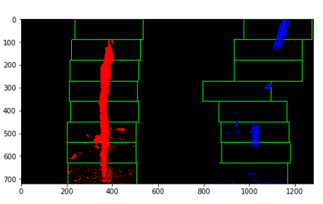

Then I did fit my lane lines with a 2nd order polynomial kind of like this:

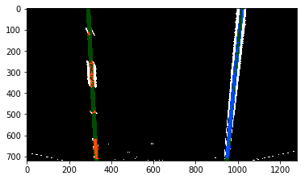

**5. Describe how (and identify where in your code) you calculated the radius of curvature of the lane and the position of the vehicle with respect to center.**

I find the left and right curvature, I did this in code cell 14, 15 and16. And I took the average of this to find the center curvature. Then I found the bottom left and right cordinates and calculated the midpoint of lanes and used the image center as reference to calculate distance away from center.

**6. Provide an example image of your result plotted back down onto the road such that the lane area is identified clearly.**

I implemented this step in code cell 22 in the function process_image(). Here is an example of my result on a test image:

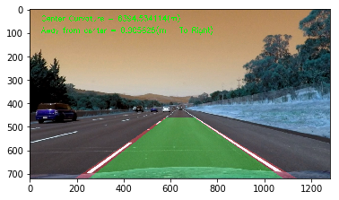

**Pipeline (video)**

**1. Provide a link to your final video output. Your pipeline should perform reasonably well on the entire project video (wobbly lines are ok but no catastrophic failures that would cause the car to drive off the road!).**

Here's a [link to my video result](https://github.com/apreddyy/ADLanedetectionPython/blob/master/project_video_out.mp4).

**Discussion**

**1. Briefly discuss any problems / issues you faced in your implementation of this project. Where will your pipeline likely fail? What could you do to make it more robust?**

I found stretching the color channels would work perfectly on harder challenge and its regular video. The problem is I have to write own opencv function for this.